Bato.to

Definition
# Source: ScreenShots Source: Provided by: [Persons Table -> ID Column: 1, Name_En Column: Motasem Essam] -> Tool: [Lightshot Program] -> From [Site: https://battwo.com] on [10/29/2025]
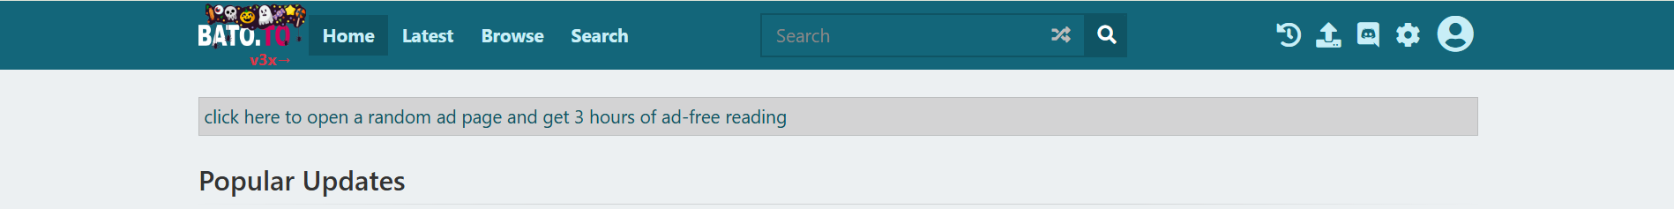
# Source: AI Source: Provided by: [Data Path: Persons Table -> ID Column: 1, Name_En Column: Motasem Essam] -> From: [ChatGPT] on [10/29/2025]
Bato.to (bato.si) is a website that hosts manga and webcomic content, primarily scanlations (fan-translated manga) and some official releases. Here’s a detailed breakdown:
- Website: https://bato.to
- Purpose: A reader-friendly platform for manga and manhwa, focusing on fan-translated content.
- Origin: Started as a community-driven alternative to other manga scanlation sites.

Key Features
# Source: AI Source: Provided by: [Data Path: Persons Table -> ID Column: 1, Name_En Column: Motasem Essam] -> From: [ChatGPT] on [10/29/2025]
a) Manga Database
- Hosts thousands of manga, manhwa, and webtoons.
- Titles are usually organized by language, genre, and release status.
- Includes chapters with sequential numbering for reading online.
b) Community-Driven
- Users can upload translations or link scanlation groups.
- Readers can comment, rate, and discuss chapters directly on the site.
- Active forums for sharing fan projects and updates.
c) Reading Features
- Clean web-based reader with navigation for next/previous chapters.
- Some chapters include volume grouping, but often chapters are standalone PDFs or images.
- Minimal ads and simple interface for easier reading.
d) Limited Metadata
- Provides basic series info: author, artist, genre, status (ongoing/complete).
- Sometimes has cover images, but official volume info is limited.

Usage
# Source: AI Source: Provided by: [Data Path: Persons Table -> ID Column: 1, Name_En Column: Motasem Essam] -> From: [ChatGPT] on [10/29/2025]
- Primarily for reading scanlations online.
- Not ideal if you’re looking for official volume lists, publication dates, or official cover images—for that, sites like MangaDex, MAL, or MangaUpdates are better.
- Focuses on community interaction and fan translation accessibility.

Summary:
# Source: AI Source: Provided by: [Data Path: Persons Table -> ID Column: 1, Name_En Column: Motasem Essam] -> From: [ChatGPT] on [10/29/2025]
- Bato.to (bato.si) = Fan-driven manga site
- Strengths: Easy online reading, community comments, scanlations
- Limitations: Minimal official metadata, volume info, and publication details

